**HeatFrost**

Game submission for the "Godot Community Game Jam - June 2018"

Game developed by:

Giorgi Beriashvili

Jorge Baptista

GDD/GDT - Version **1.0**; last edited 17/06/2018

**Summary**

HeatFrost will be an 2D endless fast-paced game where the player will have to make multiple decisions in short spans of time. The objective is to survive as long and further as possible and obtain a higher score than last time.

**Genre –** Action/fast paced, endless. 2D, **Top Down/Side view** (theme is temperature according to the game jam this game was created for)

**Audience –** anyone who likes good challenges and score-based games, trying to surpass his own or his friends high score in each new match.

**Platform –** Intended for Android (portrait view mode), but with versions for Windows/Linux/Mac, flash? Browser?

**Gameplay**

To play this game the player must maintain an ideal temperature otherwise he will die. The temperature will be displayed by a progress bar which its two extremes (left and right) will visualize coldness or hotness. The ideal temperature will be between the two extremes of the bar. The player will earn points as he progresses. The points earned will depend on current temperature of the player, he will earn more points if the temperature is stable, and less if the temperature further from stable.

The player will **constantly** move vertically (up) and will only be allowed to change its horizontal position by input.

**Level Design**

The level of the game will be composed of 3 columns and will be the only places where the player can move (horizontally):

* The left column will be the hottest and every second the player spends on this column the temperature will rise (hot)
* in the middle column the temperature will stabilize (or not change at all)
* the right column will be the coldest and every second the player stays on this column the temperature will lower (cold)

Each column will have certain obstacles that the player will need to dodge or otherwise face the deadly lose screen.

**The game will be endless, so the level must be regenerated in a seamless way alongside obstacles (obstacles being generated randomly).**

To make it harder, the player will move faster gradually shortening the span time the player has to make action decisions.

**Art (UI included)**

The type of art will be vector drawn?

Required game art assets will be:

**Color Palette (important)**

* Physical:
  + Player
  + Level background (seamless) – [can also blend with columns]
  + 3 distinct columns according to level design section, a hot one, a cold one and a stable one
  + Obstacles for each column
* UI:
  + Temperature bar (starting in middle) with two extremes, hot and cold. Requires back part of bar and front part of bar (the bar that will grow/degrow)
  + Buttons
  + Screens (main menu/front image/splash screen; lose screen/high score screen; pause screen)
  + Logotype
  + Text (buttons, etc.) – need to choose a font
  + Icon (both for “store” and representation of game
* Animations:
  + The player will require animations when changing columns.

**Controls/Input**

The only controls available to the player are the horizontal controls (left and right) to change columns and the button to pause game. [Mouse input will also be needed to click any available buttons]

When player presses horizontal input the player asset will do a certain animation (jumping). **Which means that the horizontal movement will not be instant.**

**Exemplifying Image/Bullshot**

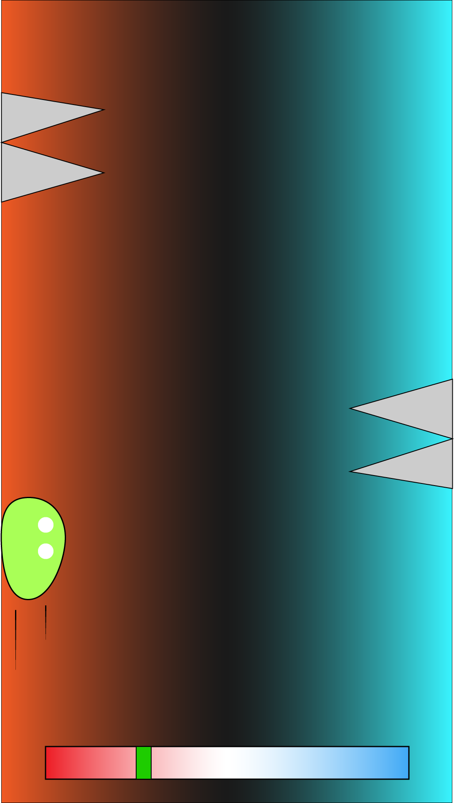(This is merely exemplificative and not related to the final product)